A faster way to simulate Computational Fluid Dynamic result through neural network

Jian Bin (Kevin), Lin

Department of Biological Engineering

Faculty of Engineering

University of Guelph

Ontario, Canada

Email:jlin17@uoguelph.ca

***Abstract-*** **Multi-phase flow is very common in industry including liquid phase such as water and oil gas. Modelling of flow parameters become interest of engineers to control flow parameters. Computational Fluid Dynamic (CFD) is utilized to predict parameters such as phase fraction, pressure, x-direction velocity through numerical method. It takes lengthy of time to run simulations even though time of simulation is only a few seconds. Engineers have to wait for long time to obtain the result. By using neural network machine learning technique, it significantly reduces the computing time with acceptable accuracy. Dam break CFD simulation took more than 50 hours to predict the flow parameters for 3 second simulation. Utilizing neural network modelling technique can be done in a few minutes. In this project, neural network was utilized to build flow pattern models to replace traditional CFD simulation. As a result, it reduces computing time dramatically**

I. Introduction

CFD is a branch of fluid mechanics which is a computer-based simulation software. It can be used to predict fluid flow parameters, heat transfer patterns and chemical reactions. The technique for CFD needs complex setup and optimization and it can not be used in real-time simulation. One of disadvantage of CFD numerical simulation is time computing expensive. For a simple simulation, it might take more than a day to get result. Pressure-implicit split-operator (PISO-SIMPLE) algorithms was used in this study. Commercially available CFD includes ANSYS and the open source is OpenFoam which was used for this project [1]. Each simulation has three major steps including pre-processing, solver selection and post-processing. The detailed procedures can be found in the method section. In this project, we utilized artificial neural network to predict the flow parameters with short lead time. It only takes a few minutes to obtain these parameters [2]. In terms of accuracy, it can achieve acceptable accuracy with less than 10% error rate compared to CFD numerical simulation. A typical CFD simulation involves tracking dam break parameters including phase fraction, pressure, x-direction velocity and y-direction velocity. They were simulated by CFD at specific time step and they served input data of neural network to train models. Four independent models were built as four output variables were required. In this study, CFD simulation took 52 hours to finish with three seconds. After building neural network models using initial output steps, models can predict next step with acceptable error rate. In other words, neural network technique has successfully applied to CFD and significantly reduced computing time.

II. Method

Computational Fluid Dynamic Simulation has pre-processing, solver selection and post processing steps. During pre-processing step geometry of interest has been defined. Geometry is overall shape of simulated object. Geometry is further divided into patches. Patches can be further divided into blocks. Then grids are applied to blocks to generate mesh. In our case, various mesh quality have been tested out including 20x20, 200x200 and 400x400. It turned out 200x200 is optimal and 400x400 it to fined. 20x20 is too coarse.

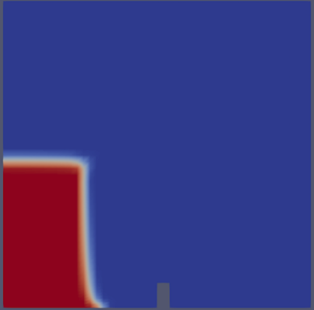 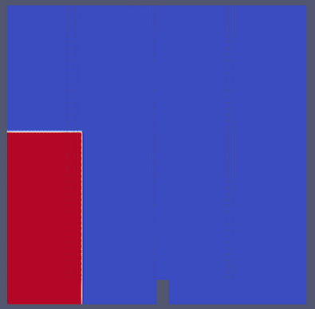 

Figure 1: 20 x 20 grids Figure 2: 200 x 200 Figure 3: 400 x400

Next step is to choose solvers to solve the equations. Finite volume method was used in this modelling. Finite volume means dividing domain into meshes. Each mesh has a finite centre. It means that flow variable such as momentum is conserved in each finite size. The total volume of centre is equivalent to domain volume. Its flux is conserved from one discretization cell to neighbouring cell. General conservation law can be represented as:

$q_{t}\left(x,t\right)+divF\left(x,t\right)=f\left(x,t\right)$ [3]

$q_{t }$ can be energy, heat at specific time point and "div” represents divergence of vector functioning at time t and space x. Pressure Implicit Split Operator (PISO) solver solves the momentum equation using one predictor step and two corrector steps. The term split refers to splitting pressure and velocity into two equations instead of one. [5] It’s used to solve pressure-velocity linked equation. [4]

For the mass conservation, the continuity equation is represented as:

$$\frac{∂ρ}{∂t}+ ∇.\left(ρU\right)=0 [3]$$

Where U is velocity, ρ is density.

A new term was introduced to the formula phase fraction γ. It ranges from zero to one. One means the cell is full of water phase and zero means the cell is full of gas phase. The phase fraction equation is:

$γ= \frac{fluid volume}{cell volume}$

The density would be:

$ρ_{m}=γρ_{1}+(1-γ)ρ_{2}$ [3]

Where $ρ_{m}$ is density of mixture. This is considered as incompressible flow case since fluid density remain same as flow moves along the flow parcel.

In post-processing step, this step involves analyze and visualize the result. Post-processing tools include commercially available “ensight” and “TecPlot” are commercial and “Paraview” is open source one which will be used in this case.

There are many algorithms to train a neural network including gradient descent which was adapted for this study. It’s first order training method. In this study, one hidden layer and one output layer were implemented. Since network has hidden layer, it’s considered as non-linear regression model. Back Propagation (BP) algorithm (BP) was used for this study. The algorithm needs input data and pass through activation function which is in the hidden layer and output the labeled value. The network finds the weights that match input and output value. The sum of squared errors were calculated.

The mechanism of network listed below.

$y=ax+b$

Weight is represented by a and bias is represented by b. The input variable x1, x2



Figure 4: Neural Network setup for dam break fluid modelling

In terms of feature selection, neighbouring cells are four cells surrounded by target cell. Each neighbouring cell has its own neighbour cell. Twenty features were collected from their neighbouring cells. Each corresponding neighbour cell has four features as well including fraction, x-direction velocity, y-direction velocity and pressure. twenty features serve as input entity output will be one of them.

III. Result and discussion:

1. Fraction model:

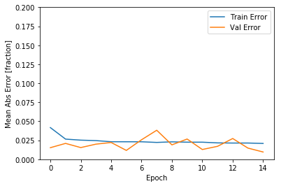 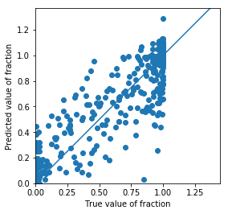

Figure 5: Mean absolute error versus Epoch Figure 6: Fraction true/predicted value comparison

1. Velocity x-axis model result

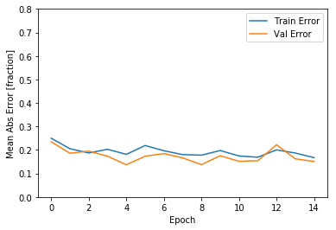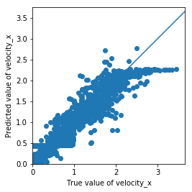

Figure 7: Velocity ean absolute error versus Epoch Figure 8: Fraction true/predicted value comparison

1. Velocity y-axis model

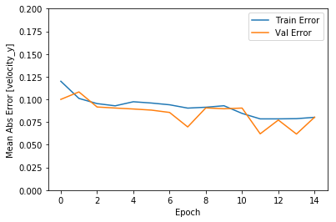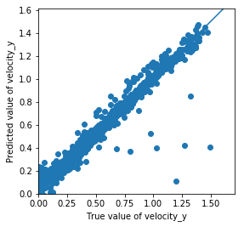

Figure 9: Velocity x-axis mean absolute error Figure 10: Fraction true/predicted value comparison

1. Pressure model

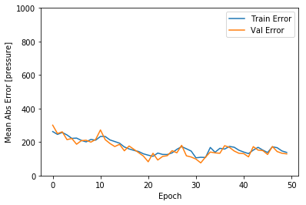 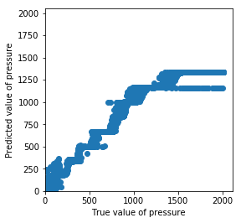

Figure 11: Velocity y-axis mean absolute error Figure 12: Pressure true/predicted value comparison

Table 1: testing set mean absolute error

|  |  |  |  |  |
| --- | --- | --- | --- | --- |
|  | Friction Model | Velocity x-axis Model | Velocity y-axis Model | Pressure Model |
| Testing set mean absolute error | 0.0098 | 0.16 | 0.08 | 130 |
| Testing set mean square error | 0.0012 | 0.048 | 0.014 | 48000 |

IV. Discussion

Four models have been successfully implemented. For fraction model, absolute error is 0.0098.

|  |  |  |  |  |  |  |
| --- | --- | --- | --- | --- | --- | --- |
|  | fraction | Velocity_x | Velocity_y | pressure |  |  |
| mse | 0.0008 | 0.00043 | 0.00028 | 0.00011 |  |  |
| rmse | 0.028 | 0.0207 | 0.0167 | 0.0105 |  |  |
|  |  |  |  |  |  |  |
|  |  |  |  |  |  |  |

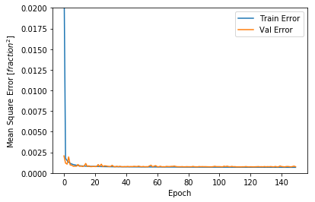 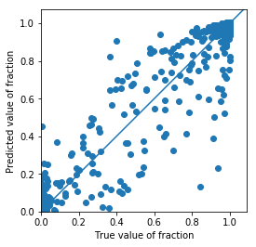

Figure :

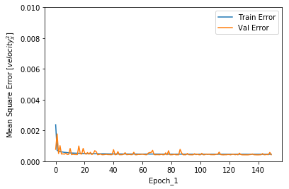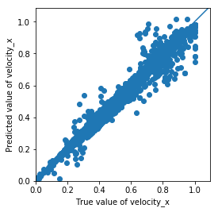

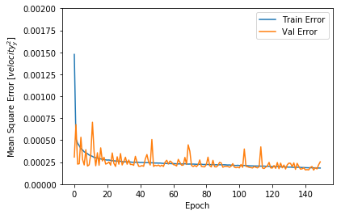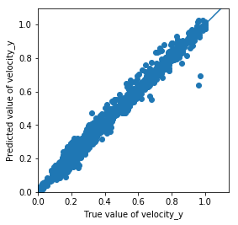

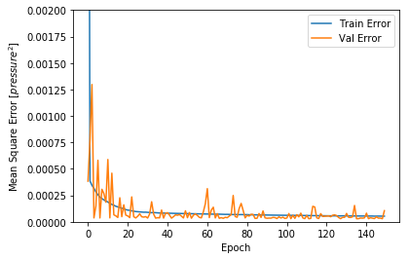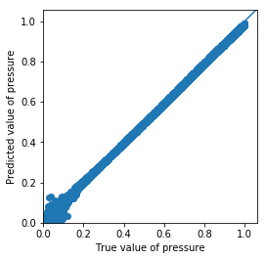

V.Conclusion

REFERENCES

1. L. Alejandro, N. William, T. Matthew, D. Stickland CFD study of Jet Impingement Test erosion using Ansys Fluent and OpenFOAM, *Elsevier*, vol. 197, vol.07, no.016, p.88-95, 2015
2. S. Sina Hossenini Boosari, Predicting the Dynamic Parameters of Multiphase Flow in CFD (Dam-Break Simulation) Using Artificial Intelligence-(Cascading Delpolyment), *Fluids*,vol. 20, no. 44, p. 2, 2019
3. S. Michael, Computational engineering-introduction to numerical methods. Darmstadt, Germany:Springer, 2006
4. R. I. Issa, *Solution of the Implicitly Discretized Fluid Flow Equation by Operator splitting*. Journal of Computational Physics. no. 62, p.40-65, 1985
5. P. Sibi, S, Allwyn Jones, P, Siddarth. Analysis of Different Activation Functions using back propagation neural networks, *Journal of Theoretical and Applied Information Tehcnology,*vol.47, no.3, p.1264-1268